Product Definition Document

(PDD)

DSE-CIDEC JAN19 PWM-Entity

Developers:

* Chuy
* Rafa
* Beto
* Yayo

Version: 0.2.9

Contents

Scope 4

Product Overview 4

Document Overview 4

Definitions 4

References 4

Customer documents 4

System Overview 4

System Purpose 4

Mechanical View 4

Environmental view 4

Product Requirements 5

No-functional Requirements 5

**Hardware Requirements** 5

Electrical Requirements 5

Report Requirements 6

REQ-DOC-020 6

REQ-DOC-021 6

REQ-DOC-022 6

REQ-DOC-023 6

REQ-DOC-024 6

REQ-DOC-025 6

REQ-DOC-026 6

REQ-DOC-027 6

Functional Requirements 7

System Requirements 7

Software Requirements 7

Appendix 7

Attachments 7

History Document 8

Disclaimer 8

# Scope

## Product Overview

DSE-CIDEC JAN19 PWM-Entity will be a system that provides the client a solution to its need of a product that responds to the requirements. A pulse width modulation entity capable to produce the velocity need by the fan, and providing a proper HMI to ease the use from the final user.

## Document Overview

This document shall explain and define the requirements needed by the client to produce the expected product.

Any requirement not defined in this document will not be incorporated to the final product. However, as a living document, is subject to be changed along the development time.

Client and Developers team must be in accordance of any change.

This document is in process of patenting, and is under the Mexico’s copyright law and cannot be copied or distributed in part or entirely.

## Definitions

Shall- denote mandatory requirement that must be follow the specifications stated in this document.

Should- represents a desired operational characteristic.

Will- refers to the performance of the system under user or any other component interaction.

# References

## Customer documents

# System Overview

## System Purpose

The DSE-CIDEC JAN19 PWM-Entity shall have the configuration described below

#### REQ-DOC-054 The whole control system shall use the SK-S7G2 Renesas Board, which generates a 10kHz PWM signal and the duty cycle is controlled by a variable resistor.

#### REQ-DOC-055 The velocity must be showed over the touch LCD Renesas Board Panel

#### REQ-DOC-056 The board SK-S7G2 will measure the engine revolutions (rpm) by a Hall effect sensor. This signal will be introduced to the board to calculate the error and the control algorithm maintain the velocity system desired making the minimum error.

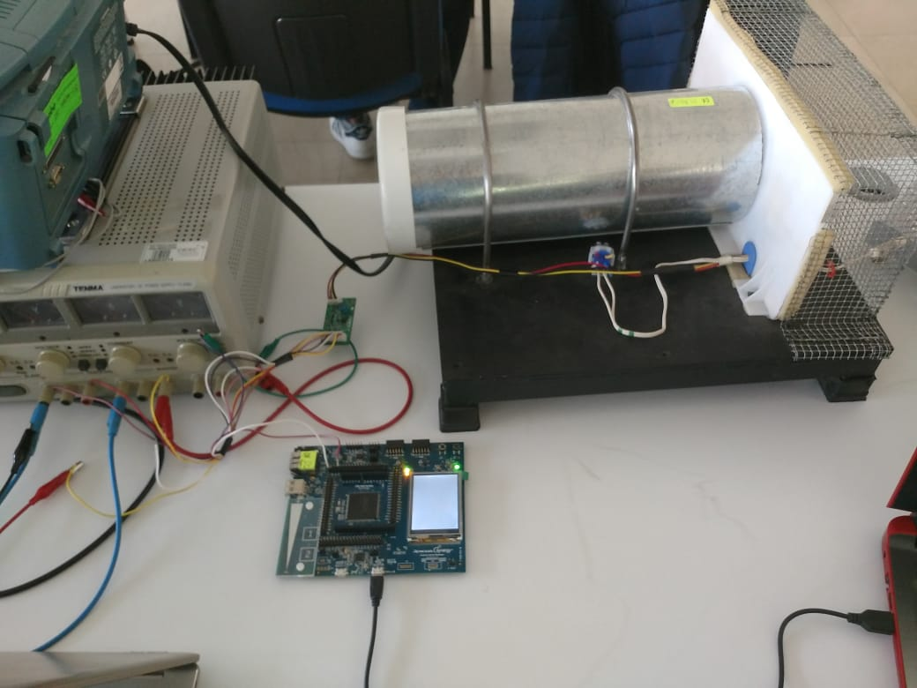

## Mechanical View

The DSE-CIDEC JAN19 PWM-Entity shall have the mechanical components described in Table 2.

Table 2 (TBD)

# Product Requirements

## No-functional Requirements

### Hardware Requirements

#### REQ-DOC-001 The device to control shall be CESEQ_C001 module engine (Appendix.Attachments-Fig.002).

#### REQ-DOC-030 The power module device shall be CESEQ_P001 (Appendix.Attachments-Fig.003).

#### REQ-DOC-032 The device to be programmed shall be Renesas YSSKS7G2E30 board (Appendix.Attachments-Fig.004).

#### REQ-DOC-034 The device to be used as HMI shall be the 320p x 240p, 2.4’’ display embedded in Renesas YSSKS7G2E30 board.

#### REQ-DOC-042 The system shall be able to use a Renesas YSSKS7G2E30 board Potentiometer.

#### REQ-DOC-057 The CESEQ-P001 shall be used as H half bridge.

#### REQ-DOC-058 The CESEQ-P001 shall protect and supply with power the CESEQ-C001.

#### REQ-DOC-059 The CESEQ-P001 shall be connected directly to the Renesas board, without any additional protection.

### Electrical Requirements

#### REQ-DOC-028 The CESEQ-P001 shall be sourced with 12 V as described in its datasheet.

#### REQ-DOC-035 The voltage source used to power the system will be capable to produce the current necessary to move properly module CESEQ-C001 engine.

### Report Requirements

#### REQ-DOC-002 The document shall have a cover page with the format as seen in Appendix.Attachments-Fig.001.

#### REQ-DOC-004 The document shall have a log with the name of the reviewers and approvers at the final page.

#### REQ-DOC-005 The document shall have a log with the historical data and modifications

#### REQ-DOC-006 The document shall have an index that shows the content of the project

#### REQ-DOC-007 The document shall have the scope of the project described in this document.

#### REQ-DOC-008 The document shall have an identification of the project: name, motivation and a brief resume as introduction

#### REQ-DOC-009 The document shall have a general description of the project

#### REQ-DOC-010 The document shall have a section with final customer deliveries. Commitments and delivery modules and dates.

#### REQ-DOC-011 The document shall have a description of development methodologies to use.

#### REQ-DOC-012 The document shall have a costumer SW delivery plan

#### REQ-DOC-013 The document shall have a control procedures description.

#### REQ-DOC-014 The document shall have an estimation section with: description of all the resources to use: Critics resources (RAM, ROM, throughput), Human Resources, infrastructure and tools.

#### REQ-DOC-015 The document shall have an analysis of the project's assumptions, restrictions, risks and problem resolutions.

#### REQ-DOC-016 The document shall have a planning description that explains: roles and responsibilities of every team mate; delivery traceability, SW requirement analysis.

#### REQ-DOC-017 The document shall have a SW architecture design with: SW block diagram; Control Diagrams with: input, outputs, noise system and data flux; call tree analysis and SW Flow Chart.

#### REQ-DOC-018 The document shall have UML diagrams with: State machines; Time diagrams and resources.

#### REQ-DOC-019 The document shall have the final % ROM usage, % RAM usage, STACK memory usage, Memory Map.

#### REQ-DOC-020 The document shall have a section which explains the Cyclomatic Complexity

#### REQ-DOC-021 The document shall explain the coding standards and conventions: Files, functions, classes and variables nomenclature, MACROs definitions, data types and Coding standards used.

#### REQ-DOC-022 The document shall explain the SW revision methodology.

#### REQ-DOC-023The document shall have a SW testing section that explains: White box testing and black box testing steps.

#### REQ-DOC-024 The document shall have a SW version release with the nomenclature and explanation.

#### REQ-DOC-025 The document shall have an explanation of GIT repository.

#### REQ-DOC-026 The document shall have a Verification and SQA section with the Functional testing and field validation evidence.

#### REQ-DOC-027 The document shall have a Calendar revision section.

## Functional Requirements

### System Requirements

#### REQ-DOC-036 The system shall control the speed of CESEQ-C001 module with a pulse width modulation (PWM) trough CESEQ-P001 power module.

#### REQ-DOC-037 The system shall use the PWM with a fix 10KHz frequency square signal.

#### REQ-DOC-038 The system shall be able to use the signal supplied by Hall effect sensor embedded within CESEQ-C001.

#### REQ-DOC-039 The system shall use 15 (fifteen) pulses to determine a whole round.

#### REQ-DOC-040 The system shall convert the frequency of the pulses to speed.

#### REQ-DOC-041 The system shall have the capability to modify and set the desired speed through an on-board potentiometer.

#### REQ-DOC-043 The system shall show over the HMI the engine speed and setpoint in RPMs.

#### REQ-DOC-044 The system shall show over the HMI the square signal work percentage.

### Software Requirements

#### REQ-DOC-045 The system shall produce a square signal.

#### REQ-DOC-046 The square signal frequency shall be of 10KHz.

#### REQ-DOC-047 The square signal frequency must have a ±@% tolerance. (TBD as Renesas Board specs)

#### REQ-DOC-048 The system shall convert the acquired pulses to RPM as: where is revolutions-per-minute (the number of rounds in sixty seconds) and is the number of pulses acquired by the system.

#### REQ-DOC-049 The system shall be able to acquire a variable voltage signal and use it as set point as user’s convenience.

#### REQ-DOC-050 The voltage signal shall be over 0V and lower 5V.

#### REQ-DOC-051 The voltage conversion to percentage shall have ± 0.05% tolerance between the calculated and the measured.

#### REQ-DOC-052 The relation between the set point and the RPM is the percentage of square signal work cycle and shall be equivalents as described in the next table:

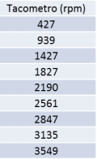 

REQ-DOC-053 The board’s display shall show the work cycle percentage, actual RPM and set point

## Derived Requirements

# Appendix

## Attachments

##### REQ-DOC-003 Fig.001

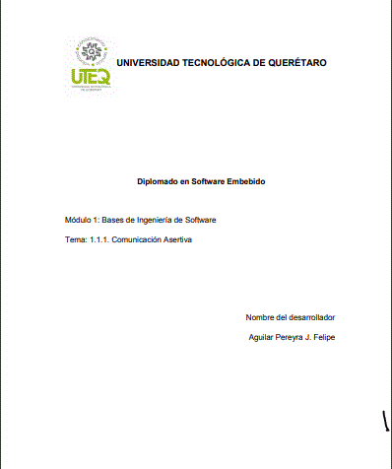

##### REQ-DOC-029 Fig.002 TBD

##### REQ-DOC-031 Fig.003

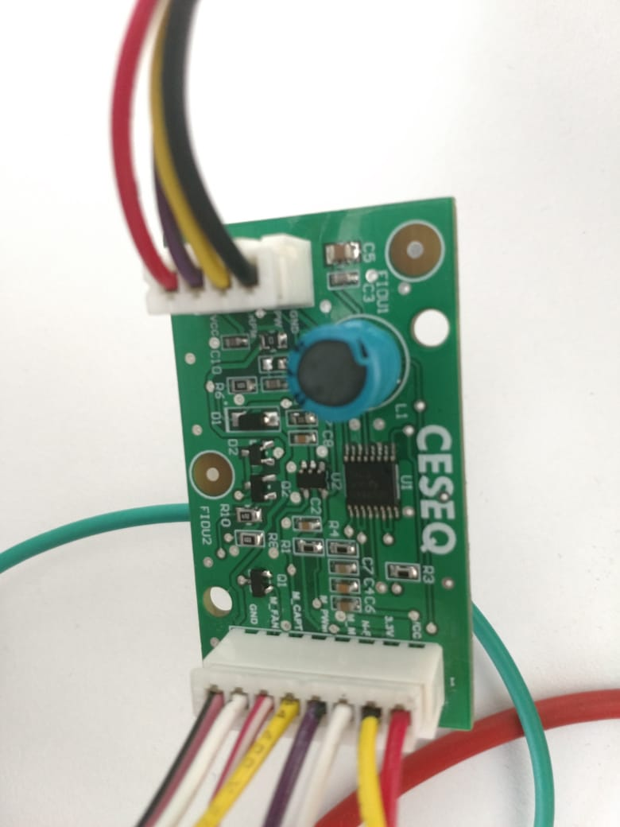

##### REQ-DOC-033 Fig.004 TBD

## History Document

|  |  |  |  |  |
| --- | --- | --- | --- | --- |
| DATE | NAME | VERSION | COMMENT | CURR. REQ |
| Dd/mm/aa | Yair Gómez | 0.2.0 | First creation of the second version of the PDD. Declaration of the name of the product and creation of the template. | - |
| Dd/mm/aa | Yair Gómez | 0.2.1 | Creation of Content Table and navigation tab. Definition of Product and Document Overview. | - |
| Dd/mm/aa | Yair Gómez | 0.2.2 | Addittion of the system purpose, definitions, mechanical and environmental view sections: attended to add Tables TBDs. First “Report Requirements” section requirement add. | - |
| Dd/mm/aa | Yair Gómez | 0.2.3 | All current Report Requirements Added. | - |
| Dd/mm/aa | Yair Gómez | 0.2.4 | All current HW and electrical requirements added. Format changed. | - |
| Dd/mm/aa | Yair Gómez | 0.2.5 | Change of format. Addition of Non-functional and Functional distribution. Optimization of requirements mapping. Addition of new column “Version”, “Current Req.” and headers to History Document table. | 35 |
| Dd/mm/aa | Yair Gómez | 0.2.6 | Addition of Req. 042 in “HW requirements” section, and current SYS requirements definition. | 44 |
| Dd/mm/aa | Yair Gómez | 0.2.7 | Start of SW-Requirements definition. | 52 |
| Dd/mm/aa | Yair Gómez | 0.2.8 | Addition of Derived requirements section | 53 |
| 31/01/19 | Yair Gómez | 0.2.9 | Definition of System Purpose  Hardware requirements updated  System photograph example attached.  Fig.003 CESEQ-P001 module image added in Apendix setction | 59 |

## Disclaimer

All the information in this document is under the